# Truncated normal distribution

PDF

Suppose a random variable $$X$$ has mean $$E\left[X\right]$$ and variance $$Var\left[X\right]$$ $$X$$

lies on the interval (a,b) with $$−\inf{}≤a≤b≤\inf{}$$

Then PDF of truncated normal distribution is defined as follows.

$$f\left(x;E\left[X\right],std\left[X\right],a,b\right)$$

= $$\frac{1}{std\left(X\right)}⋅\frac{PDF\left(\frac{X−E\left[X\right]}{std\left(X\right)}\right)}{CDF\left(\frac{b−E\left[X\right]}{std\left(X\right)}\right)−CDF\left(\frac{a−E\left[X\right]}{std\left(X\right)}\right)}$$

Where

$$PDF\left(\frac{X−E\left[X\right]}{std\left(X\right)}\right)$$ is PDF of that.

$$CDF\left(\frac{b−E\left[X\right]}{std\left(X\right)}\right)$$ is CDF of that.

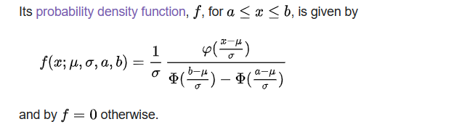

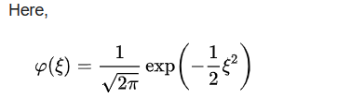

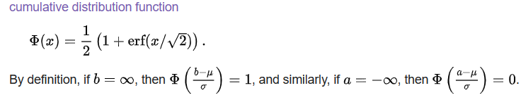

Moments

Here, I will list mean and variance for two-sided, one-sided (of lower tail) and one-sided (of upper tail).

Two sided truncation

$$E\left(X,a<X<b\right)$$

= $$E\left[X\right]−std\left(X\right)\frac{PDF\left(Z_{2}\right)−PDF\left(Z_{1}\right)}{CDF\left(Z_{2}\right)−CDF\left(Z_{1}\right)}$$

where

$$Z_{1}=\frac{b−E\left[X\right]}{std\left(X\right)}$$

$$Z_{2}=\frac{a−E\left[X\right]}{std\left(X\right)}$$

Tips:

Difference between expected value and standard deviation multiplied by slope of standard random variable.

$$Var\left[X,a<X<b\right]$$

= $$std{\left(X\right)}^{2}\left[1−\frac{Z_{2}PDF\left(Z_{2}\right)−Z_{1}PDF\left(Z_{1}\right)}{CDF\left(Z_{2}\right)−CDF\left(Z_{1}\right)}−{\left(\frac{PDF\left(Z_{2}\right)−PDF\left(Z_{1}\right)}{Z_{2}−Z_{1}}\right)}^{2}\right]$$

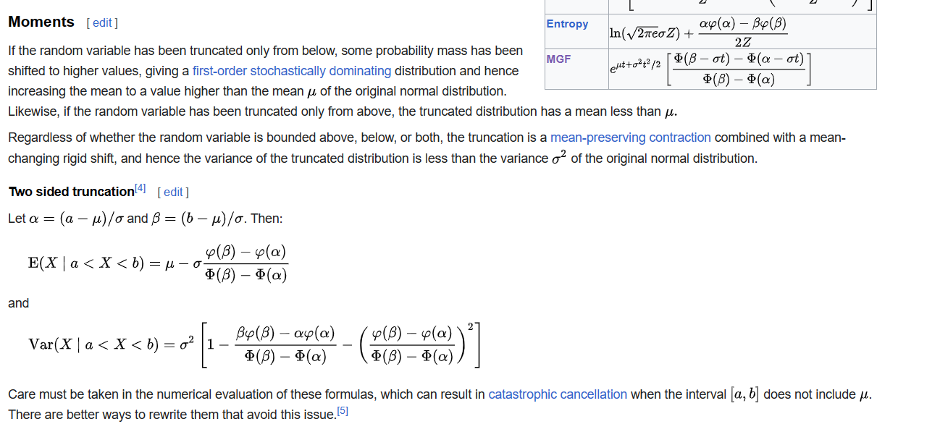

One sided truncation (of lower tail)

Apply formulas about two sided truncation with $$b$$-> inf.

In this case,

$$PDF\left(Z_{1}\right)$$ = 0

$$CDF\left(Z_{1}\right)$$ = 1

Thus, we can simplify it as follows.

$$E\left(X,a<X\right)$$

= $$E\left[X\right]+std\left(X\right)⋅\frac{PDF\left(Z_{2}\right)}{Z}$$

where

$$Z = 1−CDF\left(Z_{2}\right)$$

$$Var\left(X,a<X\right)$$

= $$std{\left(X\right)}^{2}\left[1+Z_{1}\frac{PDF\left(Z_{1}\right)}{Z}+{\left(\frac{PDF\left(Z_{1}\right)}{Z}\right)}^{2}\right]$$

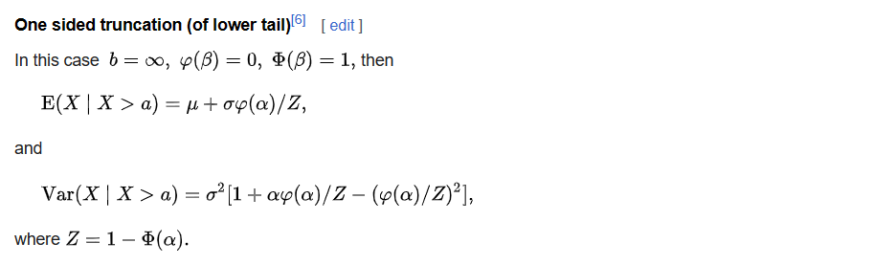

One sided truncation (of upper tail)

Apply formulas about two sided truncation with $$a$$-> -inf.

In this case,

$$PDF\left(Z_{2}\right)$$ = 0

$$CDF\left(Z_{2}\right)$$ = 0

Thus, we can simplify it as follows.

$$E\left(X,X<b\right)$$

= $$E\left[X\right]−std\left[X\right]⋅\frac{PDF\left(Z_{1}\right)}{CDF\left(Z_{1}\right)}$$

$$Var\left(X,X<b\right)$$

= $$std\left(X\right)\left[1−Z_{1}\frac{PDF\left(Z_{1}\right)}{CDF\left(Z_{1}\right)}−{\left(\frac{PDF\left(Z_{1}\right)}{CDF\left(Z_{1}\right)}\right)}^{2}\right]$$

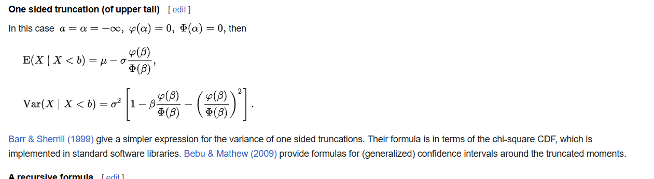

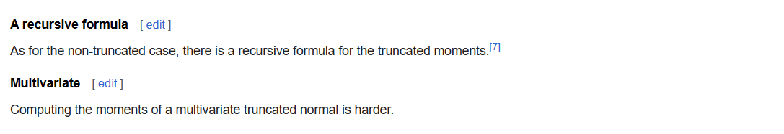

Wiki says more details:

[Barr & Sherrill (1999)](https://en.wikipedia.org/wiki/Truncated_normal_distribution#CITEREFBarrSherrill1999) give a simpler expression for the variance of one sided truncations. Their formula is in terms of the chi-square CDF, which is implemented in standard software libraries. [Bebu & Mathew (2009)](https://en.wikipedia.org/wiki/Truncated_normal_distribution#CITEREFBebuMathew2009) provide formulas for (generalized) confidence intervals around the truncated moments.

Generating values

The generating values which derived from generating function of Truncated normal distribution.

$$CDF\left(z\right)$$

= $$CDF\left(Z_{2}\right)+U⋅\left(CDF\left(Z_{1}\right)−CDF\left(Z_{2}\right)\right)$$

where

$$z$$ is standard random value of $$x$$. That is,

$$z$$ = $$\frac{x−E\left[X\right]}{std\left(X\right)}$$

Thus, we can imply that

$$x$$

= $$std\left(X\right)⋅CDF^{−1}\left(CDF\left(Z_{2}\right)+U⋅\left(CDF\left(Z_{1}\right)−CDF\left(Z_{2}\right)\right)\right) + E\left[X\right]$$

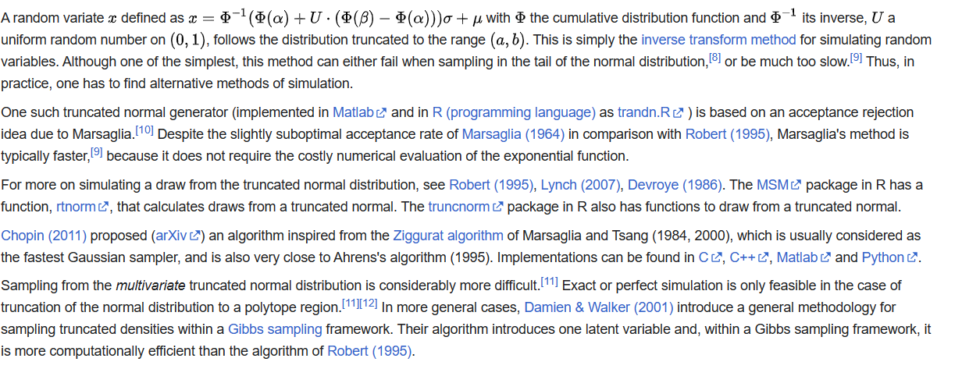

Ref

[Truncated normal distribution - Wikipedia](https://en.wikipedia.org/wiki/Truncated_normal_distribution)